

Case Study Assignment **(MKT 302)**

SCHOOL OF COMPUTER SCIENCE AND ENGINEERING

TEAM MEMBERS

**Submitted To**

**Dr. Vishwas Gupta** (Associate Professor @LPU)

**[Mittal School of Business]**

**PEER RATINGS:**

**INDEX TABLE**

|  |  |  |
| --- | --- | --- |
| S.No. | Topics | Page no. |
| 1. |  |  |
| 2. |  |  |
| 3. |  |  |
| 4. |  |  |
| 5. |  |  |

**INTRODUCTION**

* **Tanishq** is a [jewellery](https://en.wikipedia.org/wiki/Jewellery) brand of [India](https://en.wikipedia.org/wiki/India). It is a division of [Titan Company](https://en.wikipedia.org/wiki/Titan_Company), a company promoted by the [Tata Group](https://en.wikipedia.org/wiki/Tata_Group) in collaboration with the [Tamil Nadu Industrial Development Corporation](https://en.wikipedia.org/wiki/Tamil_Nadu_Industrial_Development_Corporation) (TIDCO).Tanishq's headquarters is at [Bengaluru](https://en.wikipedia.org/wiki/Bengaluru) in [Karnataka](https://en.wikipedia.org/wiki/Karnataka).
* By the end of the 1980s, the Titan company launched Tanishq in an attempt to earn its own foreign exchange, focused largely on exports. In the early 1990s, India's exchange issue was fixed, and the Titan Company chose to focus the brand on the Indian market.
* The first production plant launched in August 1992, and Tanishq's first store opened in 1996.

**BRAND**

* Tanishq has emerged as India’s fastest growing jewellery brand and is a name which signifies superior craftsmanship, exclusive designs and superlative product quality.
* The term Tanishq was coined by Mr. Xerxes Desai by marrying the words **‘Tan’** meaning body and **‘Nishk’** meaning a gold ornament.
* Tanishq has brought to the market a whole new standard of business ethics and product reliability, in the process bringing about a transformation in which jewellery is bought or sold in India.
* Not only does it abide by the stringent standards but also adheres to strict and uniform guidelines across all 328 stores across 200 cities.
* It is also the only jeweller in India with a state-of-art factory in Hosur, Tamil Nadu and takes utmost care to ensure that it complies with labour laws and environmental standards. There are 3 other units in Dehradun, Pantnagar and Sikkim as well.
* With retail sales of over Rs. 18600 crores in the last financial year.
* Tanishq was the first jewellery retail brand in India.
* Tanishq made the beauty pageant crowns for the [Femina Miss India](https://en.wikipedia.org/wiki/Femina_Miss_India) 2007.
* In May 2015, Tanishq enrolled [Deepika Padukone](https://en.wikipedia.org/wiki/Deepika_Padukone) to be the brand's ambassador.
* In 2017, Tanishq launched a sub-brand called Rivaah targeting the wedding segment.

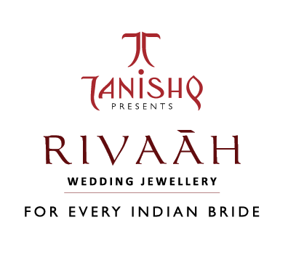

* In January 2017, the Titan group merged its *Gold Plus* stores with the larger Tanishq retail brand.
* In April 2017, Tanishq launched the sub-brand Mirayah to cater to women under their 40s.
* In December 2017, Tanishq launched the Aveer line, its first line of products for men.

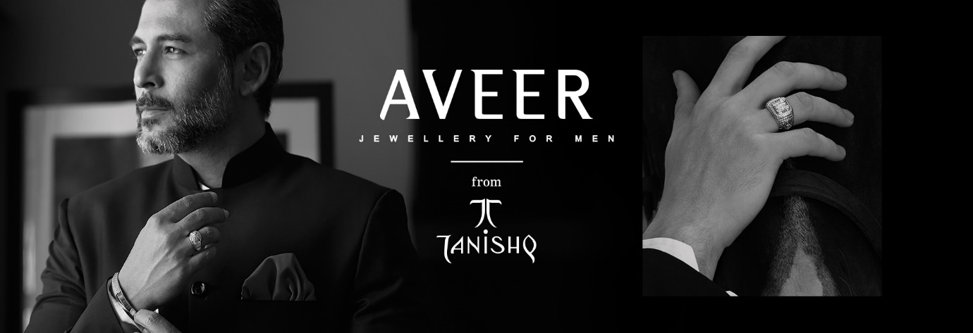

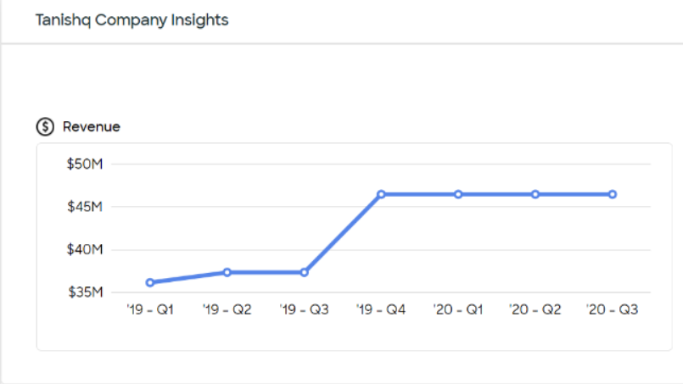

**Tanishq Competitors:**

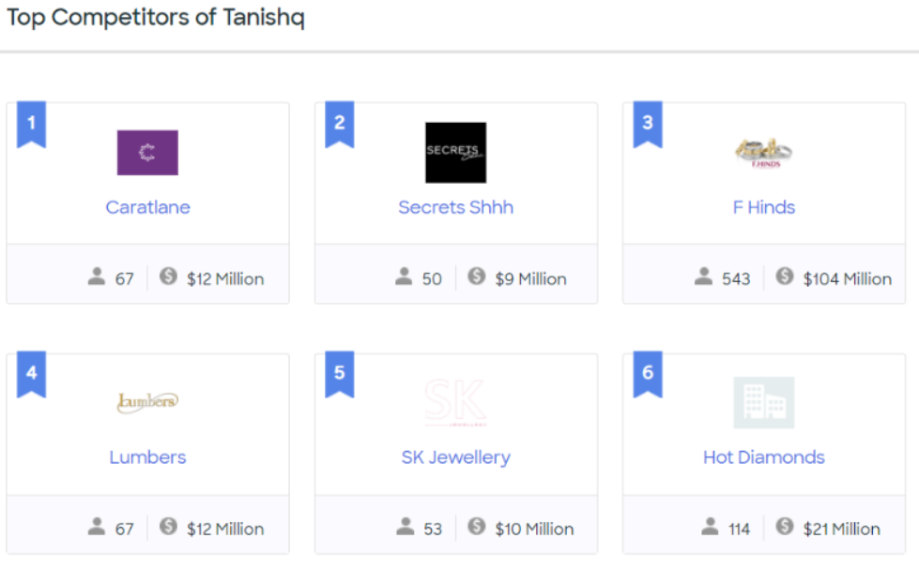

* [**De Beers**](https://www.mbaskool.com/brandguide/lifestyle-and-retail/2681-de-beers.html) **:** It is an international corporation that specialises in [diamond](https://en.wikipedia.org/wiki/Diamond_(gemstone)) exploitation, diamond mining, diamond retail, [diamond trading](https://en.wikipedia.org/wiki/Diamond_trading) and [industrial diamond](https://en.wikipedia.org/wiki/Industrial_diamond) manufacturing sectors. It operates in 35 countries and mining takes place in [Botswana](https://en.wikipedia.org/wiki/Botswana), [Namibia](https://en.wikipedia.org/wiki/Namibia), [South Africa](https://en.wikipedia.org/wiki/South_Africa), [Canada](https://en.wikipedia.org/wiki/Canada) and [Australia](https://en.wikipedia.org/wiki/Australia).
* [**Nakshatra**](https://www.mbaskool.com/brandguide/lifestyle-and-retail/3408-nakshatra.html) **:** Nakshatra Jewellery is the latest trendy diamond jewellery in the market. With a traditional name as such, traditional diamond jewellery is very common. Nakshatra Diamond Rings.
* [**Ddamas**](https://www.mbaskool.com/brandguide/lifestyle-and-retail/3022-ddamas.html) **:** Damas Jewellery is founded, the start of a remarkable legacy to offer goldsmith services in the Middle East.
* **TBZ :** Tribhovandas Bhimji Zaveri Ltd. (TBZ) is a noted [Indian](https://en.wikipedia.org/wiki/India) [jeweller](https://en.wikipedia.org/wiki/Jeweller) and jewellery retail chain based in India.[[2]](https://en.wikipedia.org/wiki/Tribhovandas_Bhimji_Zaveri#cite_note-2) Established in 1864 (156 years ago) by Tribhovandas Bhimji Zaveri in [Zaveri Bazaar](https://en.wikipedia.org/wiki/Zaveri_Bazaar), the jewellery district of [Mumbai](https://en.wikipedia.org/wiki/Mumbai),
* [**Reliance Jewels**](https://www.mbaskool.com/brandguide/lifestyle-and-retail/2877-reliance-jewels.html) **:** This is the retail unit of jewellery of reliance group founded in 2007.
* **P.C. Chandra Jewellers:** P.C. Chandra Jewellers began in 1939 and grew to be India's one of the largest jewellery house with a legacy of over eight decades.

**MOBILE MARKETING STRATEGIES and MOBILE CHANNELS :**

*Mobile marketing is the sharing of a brand or business in a way that is optimized for smartphones and other mobile devices throughout apps, social media channels, and websites.*

According to SiriusDecisions, 67% of the buying process now takes place digitally.

From a business perspective, it’s important to realize that the way in which their customers are consuming digital content has changed from desktop-based to mobile-based. In 2015, mobile use surpassed desktop use, with 51% of internet time being spent on mobile and smartphone devices.

Now let’s dive into the strategies which can we useful in terms of Marketing strategies:

1. Advertisement for specific Mobile device through Google AdWords.
2. Must launch mobile apps and responsive websites.
3. Universal Campaign
4. Location Based marketing
5. Social Media Advertisement
6. Mobile friendly content
7. Text-messaging marketing
8. Voice search optimization

**Advertisement for specific Mobile device through Google AdWords.**

Tanishq the jewellery brand from the house of Tata (turnover of Tanishq expected to be about Rs.10000 crores for the current fiscal) has been heavily trending on social media after it launched the latest television commercial.

Google AdWords enables advertisers so that they can start campaign for targeting specific mobile devices. They can advertise for specific mobile platform and devices.

Also, CPC is increasing for mobile users in comparison of desktop users. Combination of two facts i.e. increasing CPC and mobile uses leads to high ROI.

**Must launch mobile apps and responsive websites.**

Mobile app is also an effective way to approach user with a friendly environment. Increasing use of Smartphone increases app usage and its popularity among users.

**Universal Campaign**

In the history of Tanishq advertisement. There are many campaign involves which helps to increase the revenue of the company.

Tanishq has been very active about campaigning and promoting their products.

**‘#HeeronMeinHeera’ campaign:**

It was educated and creative in nature. With this campaign, Tanishq wanted the customer to set some pointers before buying any diamond jewellery. For promoting its sub-brand Mia, Tanishq made an ad campaign named ‘best at work’ as this sub-brand was launched for the working women.

Link:

https://youtu.be/gXezPfCw5JY

**‘#WomenofGold’ campaign:**

Many famous celebrities like Amitabh and Jaya Bachchan and Deepika Padukone have appeared in some Tanishq advertisements.

the brand wanted to inspire women to achieve their dreams by breaking all the stereotypes and challenging every societal norm.

Link: https://youtu.be/VjY5p1RjKWU

**Location Based marketing:**

location-based marketing techniques like geofencing to market to mobile users in a specific area.

Over 80% of marketers say location-based marketing leads to increases in three key metrics: an 85% increase in customer base, an 83% increase in response rates, and an 83% increase in customer engagement.

**Social Media Advertisement & mobile friendly content:**

The jewellery brand didn’t need to try harder. The beauty and glamour of its product has pulled people like ants to a block of sugar. And this explains the number of fans it has on the page, which, at the time of writing, was more than 484,000. But because it lacks an appropriate strategy for customer engagement, the level is ever wavering,

There some analysis buget basis so that we can eslimate overall performance of the company

**Text messaging marketing and Voice search:**

A successful text message campaign starts with giving people the chance to opt in to future messages. Three-quarters of people have no problem receiving SMS messages from companies they love, and 90% of people read those messages within three minutes of receiving them. That means text messages have astronomical open rates—people read almost 100% of text messages.

Around the world, over half of all households should own a voice-enabled device by 2022, an increase of 42% over the current ownership numbers. Of the people who don’t own a voice-enabled device, 34% of them have some interest in owning one.

Analysis in Terms of **Mobile channels**.

1. Youtube channel
2. Facebook page
3. Twitter account
4. Various giant e commerce tieups
5. SMS marketing, email marketing, SEO

Tanishq have multiple Mobile channels which can helpful for the promotion and Tarket the market for the better revenue.

Tanishq have an active youtube channel with some very good content pieces, and it has also registered its presence on Pinterest where it shares its products on various boards..

There are many good deals available on the Paytm, Freecharge and many other e commerce platform that creates a messive impact on the growth of the company

